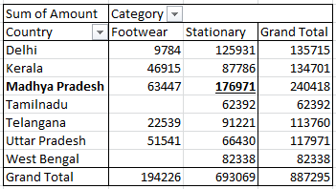**Que.1) What is the total amount of stationary bought from Madhya Pradesh?** Ans. – Rs. 176971/-

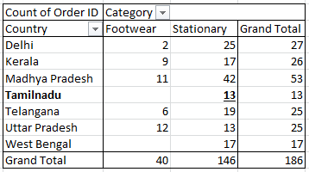Que.2) **What is the total count of stationary bought from Tamilnadu?**

Ans. – 13

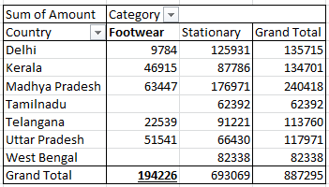**Que.3) What is the total amount spent on footwear?**

Ans. – Rs. 194226/-

**Que.4) What is the total amount of money spent for stationary in July?**

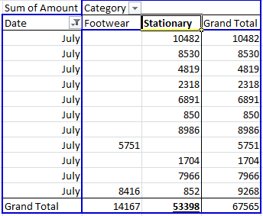Ans. – Rs. 53398/-

Que.**5) What is the count of footwear that is coming from Delhi?**

Ans. – 2

